National University
CSC 480a
Computer Science Capstone
Professor Jeffery Appel

Operational Concept Document
Immersive Robotics

December 5, 2015

Revised Version 1.2.0

Team:
KPJB

Client/Sponsor:
Professor James Jaurez, Ph.D

Team Members:
Michael Bradvica
Hardeep Kumar
Sanjay Parmar

Revision History:
12/7/15 – Overview, Problem Statement, Processes, Criteria of Acceptance
12/12/15 – Overview, Problem Statement, Users

Table of Contents

1.0 Scope
1.1 Identification 4
1.2 Document Abstract 4
1.3 System Overview 5
1.3.1 Diagrams 6
1.4 Glossary of Terms
1.4.1 Definitions 8
1.4.2 Acronyms 8
1.4.3 References 9
2.0 Product Description
2.1 Problem Statement 10
2.2 Users 12
2.3 Solution Strategy 13
2.4 Provision of Processes 15
2.5 Development Environment 16
2.6 Product Features 17
2.6.1 Prototype 17
2.6.2 Minimal 17
2.6.3 Normal 18
2.6.4 Enhanced 18
2.7 Acceptance Criteria 18

1. Scope
1.1 Identification

The following document pertains to the Operation Concept Document (OCD) regarding the Immersive Robotics project for Professor James Jaurez at National University. The following abstract and overview addresses the needs and desires to develop and build a series of interfaces. These will interact with a driver station that controls a robotic unmanned terrain vehicle that is being developed separately by the National University High School Robotics Club. However, in a larger scope, the product will be constructed as an abstract that can theoretically interact with any robotic device that accepts our library of motor control.

1.2 Document Abstract

The reasoning for the following document is to provide a concept of design and purpose for developing a driver station interface. The intended purpose is to describe the needs of the NU Robotics Club and its' lead, Professor Juarez. The document contains the following sections:
Section 1: Abstraction and Overview
Section 2: Product Description and Problem Statement
Section 2.5: Development, Feasibility, and Requirements.

1.3 System Overview

The driver station application will be an interactive, customizable experience that combines both elements of UX (user experience) and raw computer science. The driver station application will control a UTV (unmanned terrain vehicle). The UTV as a concept is an abstraction of a chassis, motors, with an Arduino micro-controller. The UTV being an abstract object is important as the driver station is only concerned with the communication aspect between itself and the micro-controller. In doing so will allow a driver to define their own experience. The core of the system will be a driver station application where a number of input devices: Xbox 360 Controller, Joystick, and Driving Wheel, will be connected to a Windows based computer. The driver station application will run on a windows device that parses the input from the devices and wirelessly transmits the commands over a Wi-Fi connection to an Arduino micro-controller. The micro-controller will then command the UTV to move accordingly. The driving station application will allow for the operator to customize their experience through a number of settings. These settings include the ability to customize the binding of input interfaces to their functions on the UTV. This means that an operator would be able to change the method of input for movement; instead of pushing forward on the joystick to go forward, the operator could bind forward movement to moving the joystick to the right. The second method of customization would be the selection of rules for control of cyber-physical factors; a cyber-physical factor could be anything from an arm lift to a hydraulically controlled device. Lastly, we want to re-imagine the driver station application from a cloud perspective. This means that a web application would be located on a web server that could physically be located anywhere. An operator would be able to access the web application from any network equipped device. This would turn the interface of the driver station into a universal application that could accept input from an infinite number of devices.

1.3.1 Diagrams
The following are diagrams to better expose the project from a visual level. These are mock representations of what is possible and do not represent any at-large architecture or commitments by the team. They are to visually express the idea put forth by this document.

Basic diagram of system:

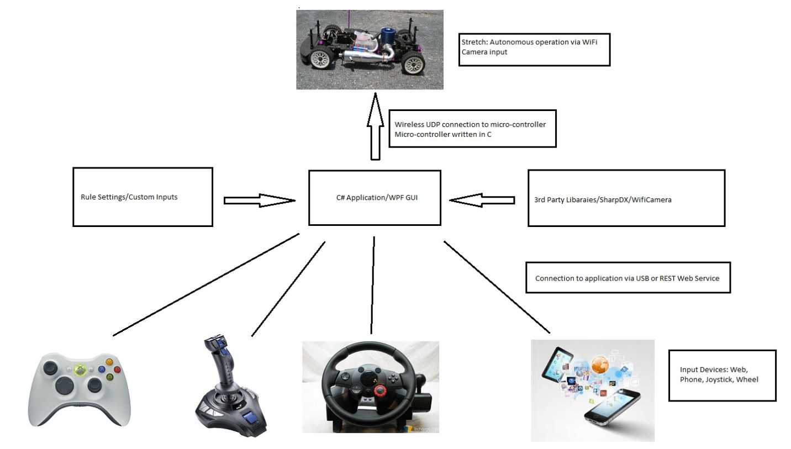

Basic Mock of GUI Application:
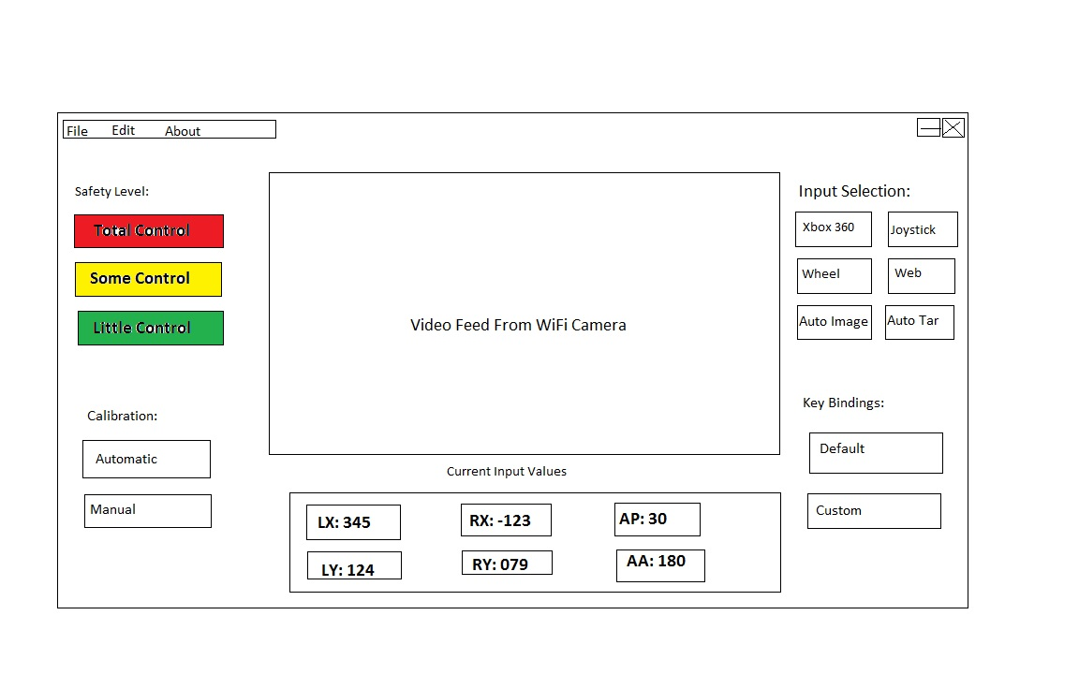

1.4 Glossary of Terms
    - Definitions
Arduino – A series of Italian based open source micro-controllers
Servo – A motor that uses are series of gears to generate movement.
Windows – Operating System developed by Microsoft.
Web Application – Another name used to describe a web site.
3rd Party Library – A partially built application that allows for partial functionality for larger software projects.
Xbox 360 – A gaming console developed by Microsoft.
DirectX – A graphics and sound API developed by Microsoft to speed up the acceleration of graphics and sound on windows based computers.

1.4.2 Acronyms
UX – User Experience
UI – User Interface
Wi-Fi – Wireless Local Area Network
RC- Remote Controlled
GUI – Graphic User Interface
UTV – Unmanned Terrain Vehicle
1.4.3 References

2.0 Product
2.1 Problem Statement

Currently the NU High School Robotics Club headed by Professor Jaurez has only a few limited options when it comes to controlling their UTV (unmanned terrain vehicle). The two options that exist right now are the ability to hard code the Arduino micro-controller, which means the UTV can only perform a limited number of functions by itself with no outside control. There is also the ability to use the Xbox 360 Controller to give the UTV limited commands, such as forwards, backwards, left, and right. The problem for Professor Jaurez is the lack of viable interfaces for controlling the UTV, and the lack of customization for the operator. There is no true tele-operation right now. The client wants human operation that can be replicated across a number of devices and UTV's. The client would eventually like the tele-operation to integrate into autonomous modes, such as an operator would give a target for the UTV to follow. Right now, the operator must use the pre-determined settings to control the car, and the calibration of the car must be hard coded into the micro-controller. This means that no user-experience computing operation exists. The client wants the ability to create an experience via the interface. The method for passing commands to most UTV's right now is through radio waves, which have a limited range of roughly 100 feet. The client would like for the driving station and UTV to communicate through a wireless network to increase the maximum range of the device to up to 1000 feet. The use of a wireless network would also provide a more universal mode of communication between the driving station application and the UTV. Another issue right now is that the input commands are also hard coded, so there is only one option for forward, and one for backwards. The client has no controls. They exist only as objects within the application, but they don't exist as controls that can be utilized or customized. The client wants a setup to initialize each individual UTV. This way a driver could build a new UTV from scratch, attach an Arduino micro-controller to the UTV, and then bind the controls to the motor-controllers of the UTV. This would provide a “true driving station” from which any Arduino controlled device could be controlled by the driver station. Finally, right now the number of input devices are limited to devices that are defined by the creator of the driver station. The client would like for a web application to be built that would re-create the driving station in a web-based form. This would allow for there to be an infinite number of possible input devices instead of the devices that we define ourselves. Overall, the problem is that the operation of the UTV only exists as “entertainment” that is predetermined. The client would like for the experience of tele-operation to be defined by the user instead of defined for the user.

2.2 Users
Technically, there is no “target user” for this interface. However, the application will be optimized for high school level competition use. The operator could range from any person of age, from child to adult, but a majority of them will be in the fourteen to eighteen year old range. It will be assumed that the operator has a limited amount of real life driving experience. The client wishes for the experience to be based on high speed interaction for what was described as, “humans under stress.” This means that the feedback given to the operator at any point is in real time and the latency between input and motor control is as small as possible. The feedback given to the operator will be minimal in order to provide, “focused metrics.” This equates to a HUD (heads-up-display) that only provides information that is necessary. The goal is to allow the operator to customize the experience to their own desire. This is in contrast to what is available right now. Currently, most driving platforms require the operator to adapt to a specific interface. The universal driving interface will allow for itself to adapt to the driver. So if the driver is a small child who would prefer to use the Xbox controller via the video feed, or if the driver is an adult who would prefer the joystick and use line-of-sight, both are perfectly acceptable. The client would like the driver to build a “profile” that will remember bindings and calibration of a certain user or device. So while it will be mandatory for the operator to configure a customized driving experience; an operator may save and reuse a “profile” so that another user may use that profile at a later time and date. The only requirements needed is that the user have amble motor skills to properly guide the RC car without any major impairments.

2.3 Solution Strategy
The following concerns the available methods for the solution:
Overarching Limitations – Because this project is not only limited to computer science, but mechanical engineering, electrical engineering, and user experience computing, we are running the risks of having to deal with issues that not only pertain to the software that we are writing, but the hardware that it is being executed on, and the devices are controlled by such hardware. This is not limited to, but including the limitations of the micro-controllers, shields, servos, motors, and stepper motors.

Code From Scratch – This method, while feasible if given a larger time scope, is not technically necessary. This would mean developing all of the DirectX wrappers ourselves, and the video processing software ourselves. This is technically not a viable option given the amount of time we have and the need for at least a basic prototype upon delivery. There are also other limitations, such as the minimal functionality of the Arduino micro-controllers and the associated shields the Arduino uses to expand its functionality. There are limitations with the small number of libraries for Arduino functionality, memory size of the micro-controller, and documentation of such devices. This is magnified by the abstraction of the driver station itself and the core functionality needed to operate the driver station.
The advantages for not only coding from scratch, but building from scratch, would be that we would be in possession of a customized solution, and the inherit newness that it would provide to the education community. This is because prior solutions for this problem simply do not currently exist. And any similar project that does exist is not documented properly, or the implications have not been fully realized.

Use What Is Available – To use what is currently available to build the project, this would mean we would be accepting limited functionality that would not be able to fulfill our requirements for the projects. The solutions that exists right now simply do not satisfy our needs for the project. Additionally, having to deconstruct and reconstruct existing hardware is a risk because of the possibility of failure from reconstructed solutions.
The advantages of using what is currently available is that we would be using readily available solutions that can be bought off the shelf that exist in pre-constructed forms.

Hybrid/3rd Party Library + Custom – By using a solution that is a custom approach, but also utilizes certain 3rd party libraries and readily available technologies would mean that the issues of interoperability would come into contention. This means that we would still have the issues of a custom solution at heart, but we wouldn't have to implement every solution. We have the risk of using technologies that were not designed to work together.
The advantages of the hybrid approach would meant that we could get what we want form a requirements standpoint, but in a much smaller amount of time. We also get to realize the potential of new convergent technologies, unique platforms, and foundations for future research.

2.4 Provision of Processes
The following will be provided for:
Driver Station – The driver station will allow for the selection and identification of input devices. The ability to either automatically or manually calibrate any device being controlled. The selection of rules to control cyber-physical factors. The ability to show feedback via the Wi-Fi camera. And lastly, to exist as a point of connection to a Web server to allow for input from networked based devices.
The Web Server/Application – The web application will re-imagine the driver station, but in a cloud based solution. This will expand the driver station to not only accept input from devices we designate, but to allow input from any networked device: mobile phone, tablet, or desktop.
Micro-controller Functionality – Integration of open hardware platforms for the UTV, operation and networking of the Arduino device that controls the ESC (electronic speed controls), servos, and stepper motors. Finally, the micro-controller needs to parse a serialized data stream passed by the driver station to control motor devices.

2.5 Development Environment
Development – Because we are utilizing the C# programming language, the ASP.NET MVC framework, and the .NET framework, the best development platform will be Visual Studio by Microsoft. As for the Arduino micro-controller, the Arduino IDE is suitable for development of the UTV. Depending on the availability and time allows, the front-end of the web application will normally be built with HTML, CSS, and JavaScript. However if time allows, the front-end may be replaced with the AngularJS framework.

Operation – Because we are utilizing the .NET framework, the host computer must be of the Windows OS type. The exact specifics of the operation system are not as important as so that the latest version of the .NET framework has been installed as to allow for proper operation. The application will come with an installation wizard to allow for easy access. The web application will also need to be installed on a server that allows for simple hosting.

2.6 Product Features
2.6.1 Prototype Functionality
The following are the features of the prototype:
- A console application that can send commands to the Arduino via Wi-Fi.
- The driver station can identify the specific input devices (360 Controller, Joystick, and Driver Wheel, etc.)
- The driver station can accept input from the specific input devices.
- A working Arduino micro-controller with the ability to parse commands.

2.6.2 Minimal Functionality
The following are the features of the minimal version:
- A GUI layer on the driver station as to allow an easier time for the driver to parse information.
- The ability for the Wi-Fi camera attached to the UTV to send video feed back to the driver station to allow the driver to watch progress in real time.
- The ability for the driver to switch between the specific input devices.

2.6.3 Normal Functionality
The following are the features of the normal version:
- Customizable input settings to allow for different key bindings.
- Manual calibration of UTV controllers.
- Rules selection option for functionality.
- Control via remote Web Application

2.6.4 Enhanced Functionality
The following are the features of the enhanced version:

- Integration of image processing library into application.

- Autonomous targeting and navigation of UTV via the image processing library.
- Multiple user input in a many to many relationship. A single user could control many devices, and many users could control a single device simultaneously.

2.7 Criteria for Acceptance
The following must be met before the application can be deemed acceptable:
- The driver station must allow for successful tele-operation from the input device to the UTV.
- Interoperability through open hardware. Any Arduino device or reconstructed hardware system can be controlled by the driver station.
- Media driver feedback through the Wi-Fi camera to allow for outside of line-of-sight operation.
- Rules customization of cyber-physical factors and limitations of electro-mechanico devices.
- Library for operation of Arduino micro-controllers to allow for portability between any Arduino based device.

